Gila River Indian Community

2024 Ambient Air Quality Monitoring Network Review

FAQ Sheet
What is an Ambient Air Quality Monitoring Network Review?
It is a document that describes the air monitoring network for the Community including monitor types, background information, summary of annual monitoring results, and changes and future recommendations to the monitoring network. This annual document identifies the purpose of each monitor and provides evidence that the operation of each monitor meet the requirements in the Federal Regulations. In other words, it fulfills requirements needed for a regulatory air monitoring program.

What are the pollutants monitored in our network?
GRIC Department of Environmental Quality (DEQ) Air Quality Program(AQP) operates air quality monitors that record ambient concentrations of two criteria air pollutants- particulate matter less than or equal to 10 microns (PM₁₀) and ozone (O₃).

What are Criteria Air Pollutants?
Criteria Air Pollutants are those that the United States Environmental Protection Agency (EPA) has defined as a potential risk to human health and the environment. These six common air pollutants include particulate matter, ground-level ozone, carbon monoxide, lead, sulfur dioxide, and nitrogen dioxide. Due to the health risks of these pollutants, EPA has set National Ambient Air Quality Standards (NAAQS) for them.

Why do we only monitor two of the six criteria air pollutants?
The Clean Air Act (CAA) requirements are designed for high population areas and emission sources. Consequently, GRIC and other tribes do not fit all of the CAA monitoring requirements. Furthermore, tribes are not required to conduct ambient air monitoring. GRIC does not monitor for these pollutants because they have been found, through discrete sampling and emission inventories, to be at background ambient (outdoor) air quality concentrations. Additionally, GRIC does not have major stationary pollution sources that emit these particular criteria pollutants that may significantly affect the NAAQS within GRIC jurisdiction.

What is the NAAQS?
The National Ambient Air Quality Standards (NAAQS) are intended to protect public health and welfare by setting limits on the allowable level of each criteria pollutant in the ambient air. These standards, also known as public health standards, were developed through scientific-based studies that indicate the level or amount of air in which the public can safely breathe. The NAAQS for Ozone (O₃) is 0.070 parts per million (ppm) based on the annual fourth-highest daily maximum 8-hr concentration, averaged over 3 years. The NAAQS for PM₁₀ is to not exceed 150 micrograms per cubic meter (μg/m3) more than once per year on average over 3 years.

What is Particulate Matter?
It is particle pollution that comes from many different types of sources. Coarse particles (between 2.5 and 10 micrometers) that GRIC monitors come from crushing and grinding operations, road dust, and agricultural operations. Particulate matter can be a problem at any time of the year and can cause serious health problems (asthma attacks, heart attacks, and strokes).

What is Ozone?
Ozone is a colorless gas found in the air we breathe. Ozone can be good or bad, depending where it occurs. Good ozone is present in the Earth’s upper atmosphere shielding us from the sun’s harmful ultraviolet rays. Bad ozone is present at ground level, where we breathe, because it can harm human health. Ozone forms when two types of pollutants (VOCs and NO_{x}) react in sunlight, usually on hot summer days. These pollutants come from sources such as vehicles, industries, power plants, and products like solvents and paints.

Where are the GRIC ambient air monitors located?
There are currently three permanent ambient air monitoring stations within the Community.
- St. Johns (SJ) (District 6) - located in a residential area within Gila Crossing Community School property. This site location monitors for Ozone and PM₁₀.
- Casa Blanca (CB) (District 5) - located in a residential area within the former Casa Blanca Community School property. This site location monitors for PM₁₀.
- Sacaton (Sac) (District 3) - located within the GRIC Office of Land Use Planning and Zoning. This site location monitors for Ozone and PM₁₀.
Meteorological data is collected at all three air monitoring sites which include measurements of ambient temperature, barometric pressure, wind speed/direction, relative humidity, and precipitation.
Why are they located there?
Air monitoring sites are strategically based throughout the Community to provide data that meets monitoring objectives: Highest Concentrations, Population Exposure, Source Impacts, Background Concentrations, Regional Transport, and Welfare Impacts. For example, the Casa Blanca site analyzes for PM₁₀ in the agricultural center of the Community and all three monitors are placed in locations within the highest population centers on the Community.

How does the 2024 Ozone monitoring data compare with previous years’ data?
Compliance with the ozone NAAQS is determined by averaging the annual fourth highest concentration for the previous three years. The 4th highest concentration for both sites in 2024 was 0.072 ppm. Therefore, the average of the 4th highest values over the last three years is 0.71 ppm for both sites. As shown in the right figure below, the ozone design value has been trending upward since 2020; however, it’s important to note that design values include days that may have been impacted by exceptional events (e.g., wildfires).
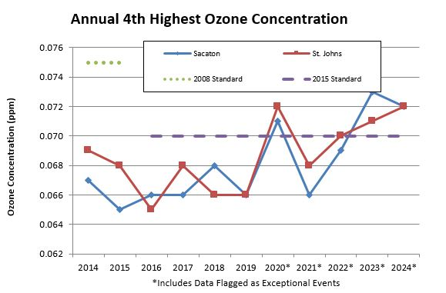
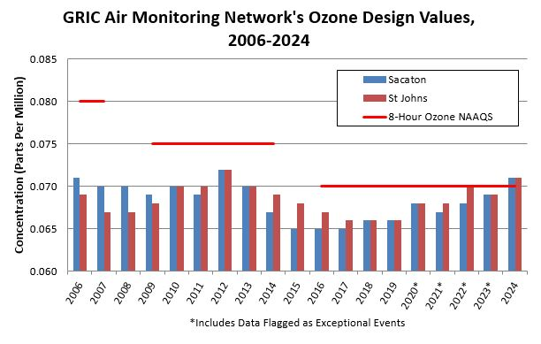

How does the 2024 PM10 monitoring data compare with previous years’ data?
Looking at the PM₁₀ graphs below, one can see the PM10 annual average concentrations are similar to last year and significantly lower than 2016-2018. Also, there was one exceedance at St. Johns in 2024 and no exceedances from Sacaton or Casa Blanca. In order to be compliant with the PM10 NAAQS, each monitoring site must not have more than one daily exceedance per year over a three-year period. The three-year average exceedance is known as the design value. From 2013 to 2022, each of the three sites has a design value greater than one as shown in the chart below. For 2023 the design value for Sacaton is 1 and for 2024 it is below 1. It’s important to note that both figures below include flagged data for exceptional events in the calculation.
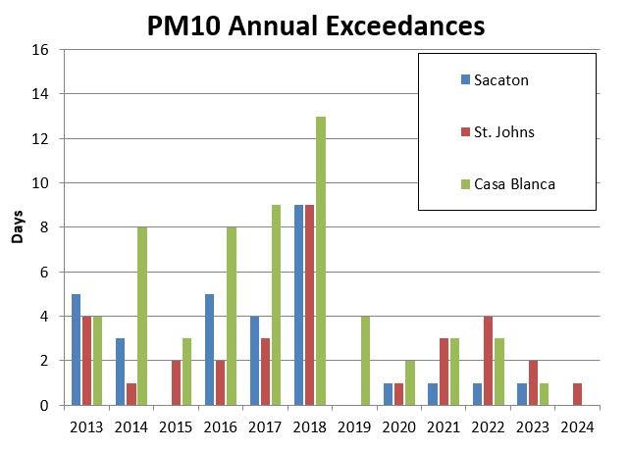
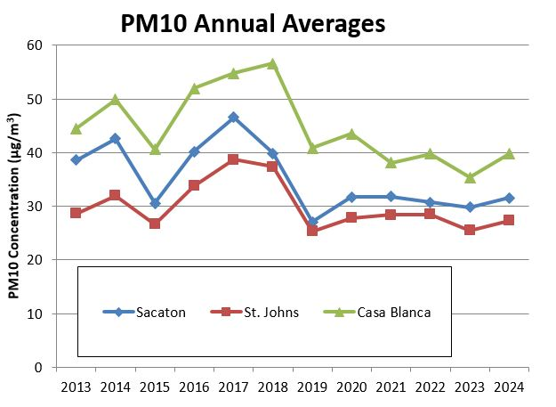

What are Exceptional Events and how do they impact the data?
An exceptional event is uncontrollable and caused by natural sources of pollution or an event that is not expected to recur at a given location. The AQP assesses any exceedances and makes an initial determination whether or not they may have been caused by an exceptional event. Those events that are determined to be exceptional are then flagged by the AQP in the AQS database. If EPA concurs that the events are exceptional, then the exceedances are removed from the calculation to determine compliance with the NAAQS.

Is the air getting cleaner?
This is a difficult question to answer because there are so many variables to factor in from year-to-year. Based on the ozone graphs above, ozone concentrations appear to be on an upward trend. However, ozone on the Community is largely influenced by the Phoenix metropolitan area, commuter traffic through the Community, day of the week, and weather conditions. A period of hot, stagnant air can easily cause ozone concentrations to become elevated. Similarly, PM₁₀ measurements are influenced by weather and local and upwind activities within the area (such as agriculture and construction). A warmer, drier season means less moisture in the soil, which may make smaller soil particles (e.g., PM₁₀) more susceptible to entrainment at lower wind speeds. Based on the PM₁₀ graphs above, the PM₁₀ concentrations appear to be on a stable or downward trend; however, this data also includes the exceptional events.

Can we get a monitor in our district?
Regulatory air quality monitors are expensive to operate and maintain and the EPA continually places additional requirements and responsibilities on air monitoring programs. Additionally, the existing air monitoring stations already exceeds the minimum monitoring objectives outlined in Federal regulations. Therefore, there are currently no plans to expand the monitoring network. In the future, pending the availability of resources, the AQP may be able to conduct short-term informational monitoring in other Districts in the Community.

